ANALYSES WITH ANGSD

./angsd -bam ../INDIVIDUAL_project/mapping/bam.filelist -GL 2 -out ../INDIVIDUAL_project/mapping/results_total/output -nThreads 8 -doMajorMinor 1 -doMaf 1 -SNP_pval 1e-6 -uniqueOnly 1 -minMapQ 20 -minQ 20 -minInd 5 -setMinDepthInd 2 -setMinDepth 7 -setMaxDepth 30 -doCounts 1 -doGlf 1 -only_proper_pairs 1 -remove_bads 1 -skipTriallelic 1 -baq 1 -ref reference.fasta -doIBS 1 -doCov 1 -makeMatrix 1 -doDepth 1

The PCA had four NA values and the beagle file was empty. Just to try I replace the NA for 0 and did the PCA

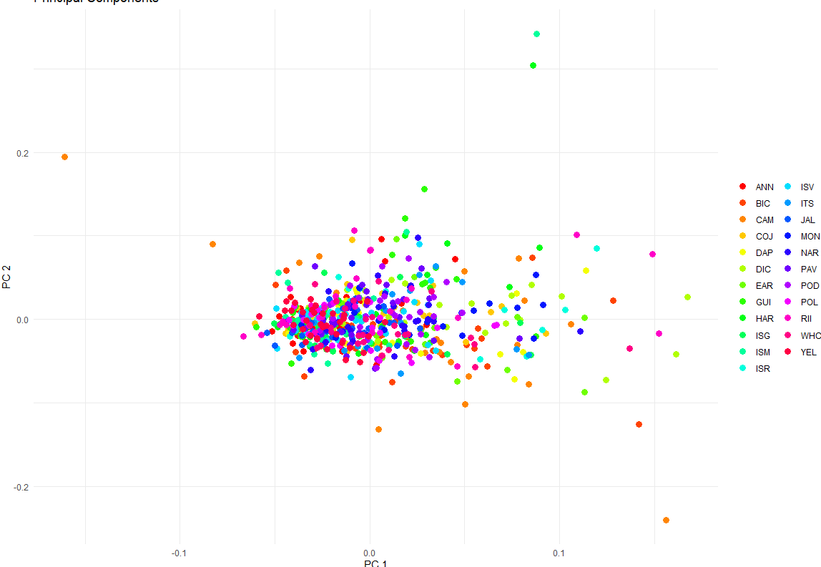

Cat output_onlydoDepth1.depthGlobal

It can be due to being too restrictive. I run the following command to check the depth of my samples

./angsd -bam ../INDIVIDUAL_project/mapping/bam.filelist -GL 2 -out ../INDIVIDUAL_project/mapping/results_total/output_onlydoDepth1 -nThreads 8 -doMajorMinor 1 -doMaf 1 -SNP_pval 1e-6 -uniqueOnly 1 -minMapQ 20 -minQ 20 -minInd 3 -setMaxDepth 30 -doCounts 1 -doGlf 2 -only_proper_pairs 1 -remove_bads 1 -skipTriallelic 1 -baq 1 -ref reference.fasta -doIBS 1 -doCov 1 -makeMatrix 1 –doDepth 1



That means that I don’t have sites with depth less than 4 but this is the total depth summed across all samples. Based on this, it seems that your min and max depth, as well as minInd are too low. These should be set to keep the main peak of the depth distribution. If you average per-sample read depth is that low, -setMinDepthInd 2 is going to be stringent. it's probably best to set it to the default (1).

NOTA: Tambien calculé depth con samtools depth from the bam files and Mean depth of 0.13. That makes sense because it is an average of all the stacks.

for bam in *.bam; do samtools depth -a "$bam" | awk '{sum+=$3} END {print "'$bam':", sum/NR}'; done > average_depths.txt

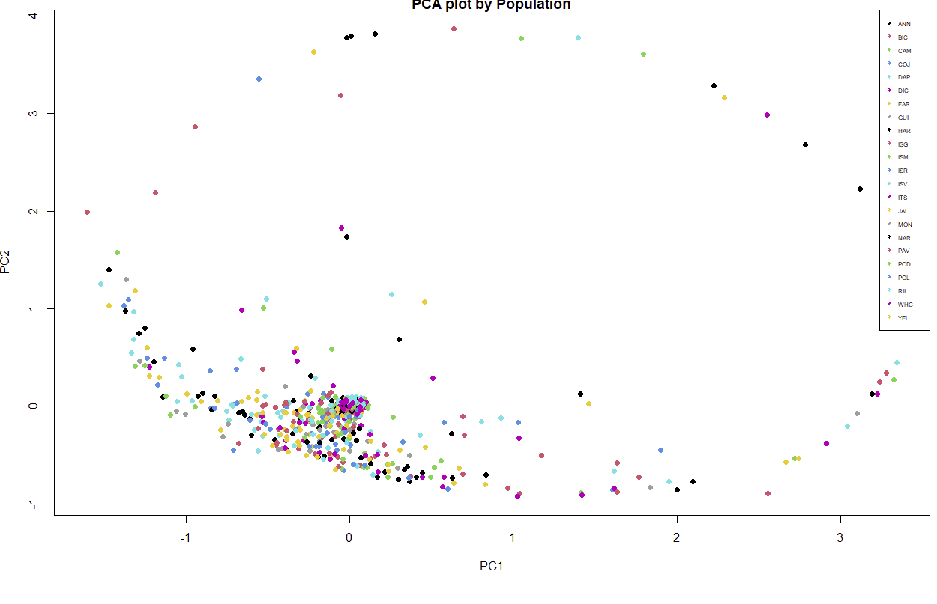

Note that sites with MAF below a certain cutoff can be discarded with -minMaf. This can be useful for PCA, admixture, or GWAS-type analyses where a minimum MAF (e.g. 5%) can help reduce noise and improve inference.

./angsd -bam ../INDIVIDUAL_project/mapping/bam.filelist \

-GL 2 -out ../INDIVIDUAL_project/mapping/results_total/minmaf0.05 \

-nThreads 8 -doMajorMinor 1 -doMaf 1 -SNP_pval 1e-6 \

-uniqueOnly 1 -minMapQ 20 -minQ 20 -minInd 3 -setMaxDepth 30 \

-doCounts 1 -doGlf 2 -only_proper_pairs 1 -remove_bads 1 \

-skipTriallelic 1 -baq 1 -ref reference.fasta \

-doIBS 1 -doCov 1 -makeMatrix 1 -doDepth 1 -minMaf 0.05

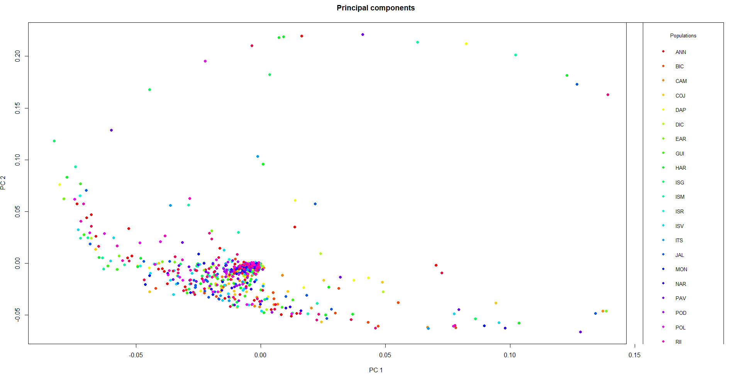

Exactly the same result. minMaf 0.05 didn’t do anything

Hago el SFS de ANN a ver que sale. Primero tuve que hacer un bam.file list con todos los individuos que pertencen a la población de ANN ls ./ANN*.bam > ANN.bam.filelist. En este caso no tuve que hacer samtools index porque ya lo había hecho anteriormente y estan todos los ficheros indexados.

./angsd -bam ../INDIVIDUAL_project/mapping/ANN.bams.filelist -ref reference.fasta -out ../INDIVIDUAL_project/mapping/results_total/ANN_SFS -nThreads 8 -uniqueOnly 1 -remove_bads 1

-only_proper_pairs 1 -minMapQ 20 -minQ 20 -minInd 3 -setMinDepthInd 1 -setMaxDepth 30 -doCounts 1 -GL 2 -doSaf 1